Weekly Work Report 6/28/2024

**This Week:**

**EEG Data Analysis:**

**TagHandMenuPumpTime & TagClickTime VS. EEG Channels**

**About MatLab**

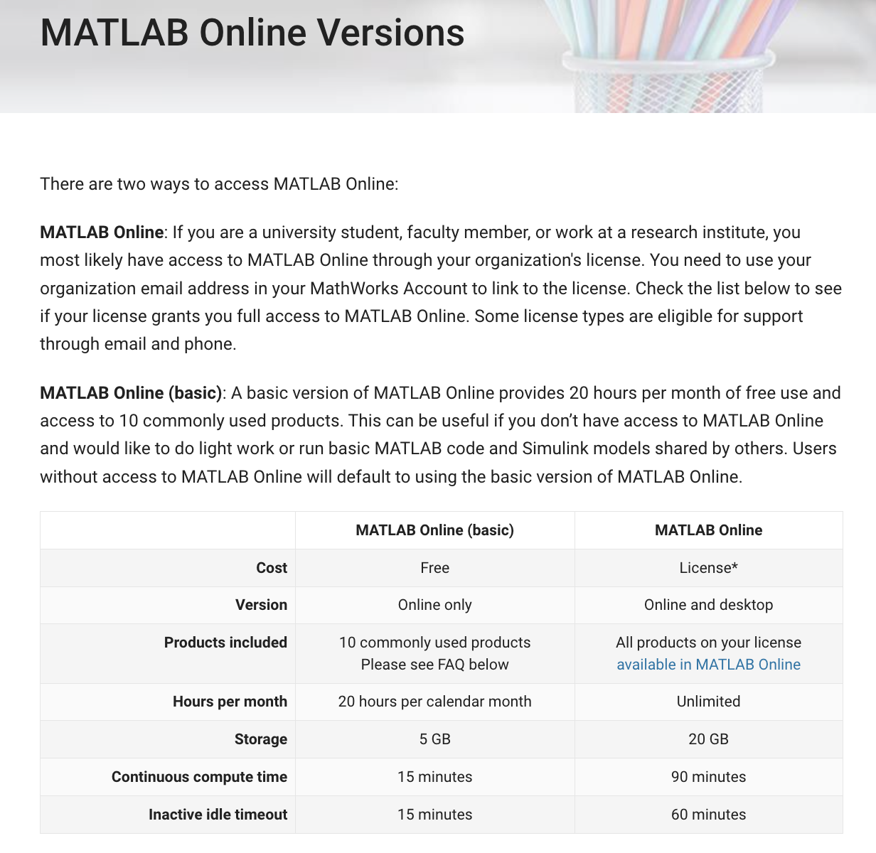

1. **WMC**
   1. WMC processing: <https://englelab.shinyapps.io/taskscoring/>
2. **Click vs EEG**
3. **Working on the EEG Dataset**
   1. Meeting with Wiam and Gai to Discuss EEG Signal Noise Reduction and Feature Extraction
   2. EEG data analysis

***preprocessing is an essential step in EEG analysis***

<https://neuraldatascience.io/7-eeg/erp_preprocessing.html>

Thus depending on where the EEG data were recorded, they will likely contain a fairly distinct peak in the frequency spectrum at 50 or 60 Hz.

filtering, re-referencing, and resampling.

https://blog.csdn.net/zyb228/article/details/106216744

# **Filtering EEG Data**

Human EEG largely comprises signal power in a range of frequencies from 1–30 Hz

Low Frequency (< 1Hz)

High Frequency (> 30 Hz)

Threshold **low pass filter cutoff**

**aliasing**. This occurs when a high-frequency signal is sampled at a rate lower than the frequency of the signal, and the result is an artifact (an artificial signal that distorts our true signal) at a much lower frequency than the actual high-frequency source.

Simply knowing that aliasing causes high-frequency noise to be represented in the data as low-frequency artifacts — and that for this reason it’s necessary to use a low-pass filter — is the most critical thing for someone doing EEG research

This means that by reducing the power of the signal at the frequencies above and below the range of experimental interest, we can reduce noise with minimal impact on the signals of interest. This process is called **filtering**.

**Next Week:**

* Literature Review on EEG Signal Features
* Schedule a Meeting with Wiam and Gai to Discuss EEG Signal Noise Reduction and Feature Extraction
* Continue EEG data preprocessing
* Perform Data Extraction for WMC